**Allosteric Enzymes: Properties and Mechanism | Microbiology**

**Properties of Allosteric Enzymes:**

Allosteric or Regulatory enzymes have multiple subunits (Quaternary Structure) and multiple active sites. Allosteric enzymes have active and inactive shapes differing in 3D structure. Allosteric enzymes often have multiple inhibitor or activator binding sites involved in switching between active and inactive shapes.

Allosteric enzymes have characteristic “S”-shaped curve for reaction rate vs. substrate concentration. Why? Because the substrate binding is “Cooperative.” And the binding of first substrate at first active site stimulates active shapes, and promotes binding of second substrate.

A modulator is a me­tabolite, when bound to the allosteric site of an enzyme, alters its kinetic characteristics. The modulators for allosteric enzyme may be ei­ther stimulatory or inhibitory. A stimulator is often the sub­strate itself. The regulatory enzymes for which substrate and modulator are identical are called homo-tropic.

When the modulator has a structure different then the substrate, the enzyme is called heterotropic. Some enzymes have more then one modulators. The allosteric enzymes also have one or more regulatory or aliosteric sites for binding the modulator. Enzymes with several modulators generally have different specific binding sites for each (Fig. 12.15).

**[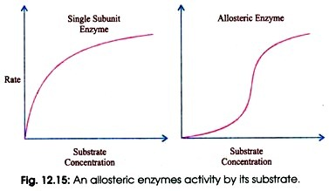](http://cdn.biologydiscussion.com/wp-content/uploads/2016/11/clip_image015_thumb6.jpg)**

The sigmoid curve is given by homo-tropic enzymes in which the substrate also serve as a positive (stimulator) modu­lator (12.16). Curve for the non-regulatory enzymes is hy­perbolic, as also predicted by the Michaelis-Menten equa­tion, whereas allosteric en­zymes do not show Michaelis- Menten relationship because their kinetic behaviour is greatly altered by variation in the concentration of modula­tors.

**[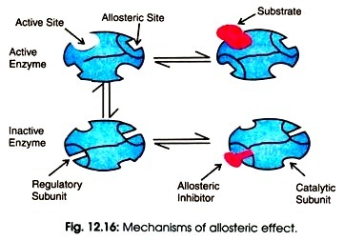](http://cdn.biologydiscussion.com/wp-content/uploads/2016/11/clip_image017_thumb8.jpg)**

**Mechanism of Action of Allosteric Enzymes:**

**Two general models for the inter-conversion of inactive and active forms of allosteric enzymes have been proposed:**

**(a) Simple sequential model:**

This model was proposed by Koshland Jr. in the year 1966. According to this theory, the aliosteric enzyme can exist in only two conformational changes individually. Consider an aliosteric enzyme consisting of two identical subunits, each containing an active site (Fig. 12. 17A).

The T (tense) form has low affinity and the R (relaxed) form has high affinity for substrate. In this model, the binding of substrate to one of the subunits induces a T → R transition in that subunit but not in the other subunits.

**[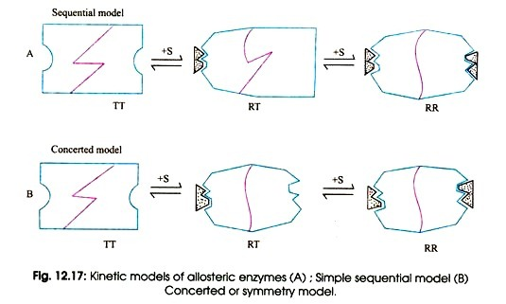](http://cdn.biologydiscussion.com/wp-content/uploads/2016/11/clip_image018_thumb6.jpg)**

**(b) Concerted or Symmetry Model:**

This model was proposed by Jacques Monod and his colleagues in 1965. According to them, an allosteric enzyme can exist in still two conformations, active and relaxed or inactive form.

All subunits are either in the active form or all are in inactive form. Every substrate molecule that binds with enzyme increases the probability of transition from the inactive to the active site. The effect of allosteric activators and inhibitors can be explained quite easily by this model.

An allosteric inhibitor binds preferably to the T form whereas an allosteric activator binds to the R form (Fig. 12.17B). An allosteric inhibitor shifts The R → T conformational equilibrium towards T. Whereas an allosteric activator shifts it toward R.

The result is that an allosteric activator increases the binding to substrate of the enzyme, whereas an allosteric inhibitor decreases substrate binding (Fig. 12.18). Symmetry is conserved in this model but not in the sequential model.

**[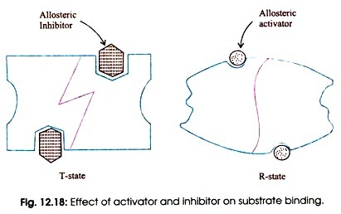](http://cdn.biologydiscussion.com/wp-content/uploads/2016/11/clip_image020_thumb5.jpg)**